Media Information

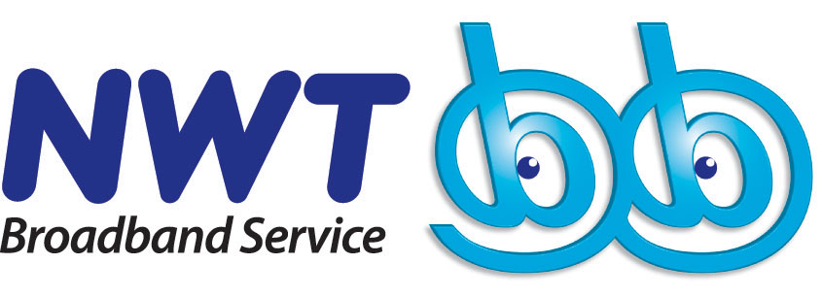 Offers Tickets for the First

“ - Metro Broadcast Eason Chan 05’ Concert”

(17 February 2005 – Hong Kong) Following NWTmusic.com’s exotic offer, the “Wayne Online In Love Valentine” gift pack, NWT unveils the second hit, giving its customers of NWTmusic.com, broadband, NetTalk and IDD an exclusive privilege to enjoy Eason Chan’s debut in 2005 – “NWTmusic.com - Metro Broadcast Eason Chan 05’ Concert”.

From now through 15 March, customers signing up for NWTmusic.com “Star” membership and NWT bb broadband service plan will receive two free tickets for the “NWTmusic.com - Metro Broadcast Eason Chan 05’ Concert”. What’s more, customers who subscribe to NetTalk personal line or 009 IDD service will automatically enter a lucky draw to win a pair of free tickets to the concert. Please refer to the attachment for offer details.

NWTmusic.com, an online music portal, launched jointly by NWT and Metro Broadcast last December has drawn an overwhelming response from music lovers in town. To further accelerate the development of the local music industry, the two companies are joining hands again to organize the “NWTmusic.com - Metro Broadcast Eason Chan 05’ Concert”, which is Eason Chan’s first solo concert this year. Leveraging on this long-awaited concert, Eason Chan will certainly perform his best by bringing a collection of memorable, enticing melodies and love-inspired lyrics, which will mark a new height in his music profession.

“NWT, the Next Generation Broadband Service Provider, is committed to delivering to its customers unique and fascinating contents. We live up to our mission by sponsoring the “NWTmusic.com - Metro Broadcast Eason Chan 05’ Concert”. Our goal is to bring customers quality telecom services and to give them privileges such as meeting their favourite superstars in person and seeing their amazing live performance. This is just a starting point and more excitements will follow,” said Peter Hung, Vice President, Marketing of NWT.

“NWTmusic.com - Metro Broadcast Eason Chan 05’ Concert” will be staged at 8pm on 27 March 2005 (Sunday) at Hall 3, 7/F, Hong Kong Convention & Exhibition Centre, Hong Kong. Tickets will not be sold publicly. Information of how to obtain tickets can be found at www.nwtmusic.com.

NWTmusic.com, one of the local pioeneering music platforms delivering a collection of music, entertainment contents and consumption, is achieved by combining the power of broadband and radio broadcasting. It aims to promote legal music downloads and bring online surfers experiences of compelling, diversified music.

Customer Registration Hotline: 1233

Enquiry: www.nwtmusic.com / www.nwtbb.com

About New World Telecommunications Limited
Established in 1995, New World Telecom (NWT) is a member of New World Development Company Ltd. Backed by its advanced Next Generation Network, NWT has evolved from a traditional telecom carrier into a Next Generation Broadband Service Provider offering a wide spectrum of unparalleled integrated communication solutions, applications and content services, such as broadband, IP telephony, VPN, IPLC, system integration, wireless solutions, local and international voice services, etc.

NWT has continuously expanded its business coverage by investing in both local and international network infrastructure, and establishing bilateral partnerships with 100 global incumbents and major carriers. In addition, NWT has obtained appropriate facility-based licenses and has established Point-of-Presence facilities and offices in strategically selected countries and regions, including the US, Taiwan, the UK and Singapore.

For details, please visit www.newworldtel.com.

For enquiries, please contact:
New World Telecommunications Limited
Eva Tang
Tel: (852) 2133 7198 / (852) 9214 7572
Fax: (852) 2133 0796
E-mail: eva.tang@newworldtel.com

Cindy Ng
Tel: (852) 2133 7199 / (852) 9214 7232
Fax: (852) 2133 0795
E-mail: cindy.ng@newworldtel.com

Appendix I

Details of Service Packages are as below:

Service Item | Monthly Rental | Contract Period | Your Privileges
3M | HK$158 | 18-month | 6-month NWTmusic.com  “Star” membership  +  2 tickets of “NWTmusic.com - Metro Broadcast Eason Chan 05’ Concert”
6M | HK$188 | 18-month
6M | HK$263 | 24-month | 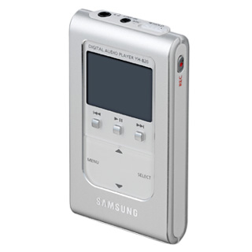  NEW  Samsung YH-820 4GB MP3 Player  with colour LCD display  (Original Price: $2,480)  +  6-month NWTmusic.com  “Star” membership  +  2 tickets of “NWTmusic.com - Metro Broadcast Eason Chan 05’ Concert”



Service Item | Monthly Rental | Contract Period | Value-added Services | Your Privileges
Basic Package | HK$39  ~ including UNLIMITED minutes for local calls | 12-month | FREE  Value-added Service Package includes: Call Waiting, Call Forward, Call Conference, Speed Dialing, Appointment Reminder, Caller Number Display, Remote Call Forward, Block-the-blocker, Do-not-disturb, IDD Security, and Call Hold. | 6-month NWTmusic.com  “Star” membership  +  Lucky Draw to win  2 tickets of “NWTmusic.com - Metro Broadcast Eason Chan 05’ Concert”



Customers who register for NWTmusic.com and 009 IDD will automatically enter a lucky draw to win two tickets for the “NWTmusic.com - Metro Broadcast Eason Chan 05’ Concert”. As long as they make a call accumulating up to nine minutes, they will have a chance to enter the lucky draw. More calls they make, the more chances they will have of winning the concert tickets. All call records are based on the NWT system.

Customer Registration Hotline: 1233

Enquiry: www.nwtmusic.com / www.nwtbb.com

